INTEGRATED SCIENCE
SECTION A
- What name is given to the young one of a cat?
__________________________________________________________
- In which way can heat be useful to man?
__________________________________________________________
- State any one physical process involved in the formation of clouds.
__________________________________________________________
- Name the body organ which store information.
__________________________________________________________
- Why is a duck billed platypus called a mammal yet it reproduces by laying eggs?
__________________________________________________________
- State one way of preventing metals from rusting.
__________________________________________________________
- How is slashing around the compound help to control the spread of malaria.
__________________________________________________________
- What is extended family?
__________________________________________________________
- Which type of soil does do not keep water for long?
__________________________________________________________
- Give any one example of a nocturnal animal.
__________________________________________________________
- Name one body part where a thermometer is fixed to take the temperature.
__________________________________________________________
- State one advantage of paddock grazing in goat keeping.
__________________________________________________________
- How is a tongue useful in the digestion process?
__________________________________________________________
- What happens to a plant if its planted in a vase in a dark room which has a small window to let in light.
__________________________________________________________
- Why should food kept for future use be properly covered?
__________________________________________________________
- In the space below draw a diagram to illustrate that heat travels through solids.

- How can effects of floods be controlled in the environment?
__________________________________________________________
- Suggest one way of maintaining the digestive system in good working condition.
__________________________________________________________
- In which way can a poultry farmer control poultry diseases in the poultry house?
__________________________________________________________
- What activity can be done by a primary six boy in order to promote environmental sanitation?
__________________________________________________________
- What is friction?
__________________________________________________________
- Why teeth should be brushed after a meal.
__________________________________________________________
- How is castration important in live stock farming?
__________________________________________________________
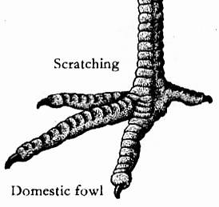
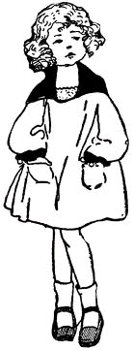

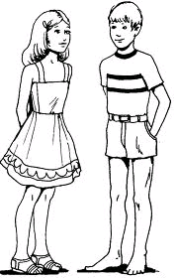
- Name the type of family shown below.




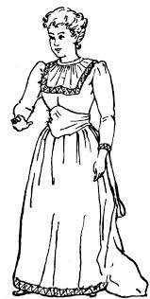

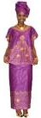

__________________________________________________________
- What type of change occurs when a leopard dies of an illness?
__________________________________________________________
- How do some plants reduce the rate of transpiration?
__________________________________________________________
- How can wind be useful I environment?
__________________________________________________________
- Give a reason why a nurse shakes thermometer before taking the temperature reading.
__________________________________________________________
- Identify any one product from a Marino sheep.
__________________________________________________________
- Name any one soil pollutant.
__________________________________________________________
- How can water promote personal hygiene??
__________________________________________________________
- Study the diagram of a bird’s foot and answer the questions that follow.

- What do bird’s with such kind of foot feed on?
__________________________________________________________
- What are enzymes?
__________________________________________________________
- Apart from having a latrine , name any one other item a healthy home should have.
__________________________________________________________
- Give one way conduction of heat is applied in our daily life.
__________________________________________________________
- State one advantage of biological changes in the environment.
__________________________________________________________
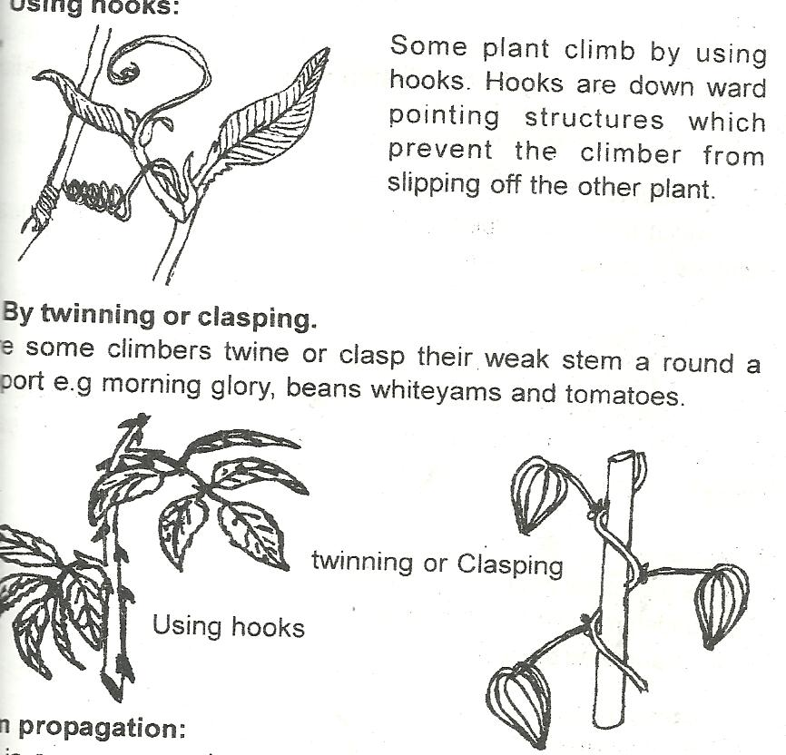
- How does a plant in the diagram below get support in order to get enough sunlight?

__________________________________________________________
- How does planting trees control soil erosion in the compound?
__________________________________________________________
- Name one material used for making composite manure.
__________________________________________________________
SECTION B
- a) Define volume of an object.
__________________________________________________________
b) How can volume of an irregular object be found?
__________________________________________________________
c) List down any two examples of irregular objects.
- ________________________________________________________
- ________________________________________________________
- a) State any two characteristics of living things.
- _________________________________________________________
- _________________________________________________________

b) Name any two major groups of living things.
- _________________________________________________________
- _________________________________________________________
- Study the human body system below and answer questions that follow;
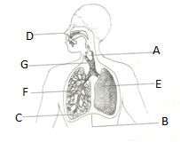
- Name the parts labeled G and F.
- G_____________________________________________________
- F_____________________________________________________
- To which system of the body does the diagram belong?
__________________________________________________________
- State one bad health practice that may affect proper functioning of the system.
__________________________________________________________
- a) Which component of air is used by plants to make food?
_________________________________________________________
b) Other than the above component you have named above, name any two other components of air.
__________________________________________________________
c) How does planting of many trees in environment help to reduce the component named in 44(a) above?
__________________________________________________________
- a) Name any one product got from poultry farming.
____________________________________________________________
b) How is poultry farming important to a baking industry?
_____________________________________________________________
c) Why is it not advisable to keep turkeys together with chicken in the same room?
_____________________________________________________________
- Write down any one disease of poultry.
__________________________________________________________
- a) What is dehydration?
_____________________________________________________________
b) State any two causes of dehydration.
- _________________________________________________________
- _________________________________________________________
c) Suggest one way you can prevent one from becoming dehydrated.
__________________________________________________________
- Match the changes that takes place in the environment in A with their descriptions in B
A B
i. Flood Abrupt falling of a mass of soil covering another area
ii. Drought -Sudden shaking of the earth which takes short time
- Landslides - Much amount of water occupying an area of land.
- Earth quake - Long period without water (rain)
- Flood ___________________________________________________
- Drought ___________________________________________________
- Landslides ___________________________________________________
- Earth quake ________________________________________________
- a) What are carnivorous mammals?
________________________________________________________
b) State any two characteristics of carnivorous mammals.
- _________________________________________________________
- _________________________________________________________
c) Give any one example of a carnivorous mammal.
_________________________________________________________

- a) Who is causality?
_________________________________________________________
b) Give any two reasons for giving first aid.
_________________________________________________________
c) Identify one example of first aid kit
- a) State any two effects of heat on matter.
- _________________________________________________________
- _________________________________________________________
b) Convert 20⁰c to ⁰F

- a) How are the following types of weather important in environment?
- Sunny________________________________________________________
- Windy____________________________________________________
b) During which weather can a Campbell sunshine recorder used?
_________________________________________________________
c) How does wind help to dry wet clothes?
_________________________________________________________
- a) Name any two types of families.
- _________________________________________________________
- _________________________________________________________
b) State any two roles of a father at home.
- _________________________________________________________
- _________________________________________________________

- Study the diagram below and answer questions that follow;
sublimation
Gas
Q
Condensation
M N
P

- Name the states of matter labeled Q and P.
- Q _______________________________________________________
- P ________________________________________________________
- Mention the processes of change of states of matter labeled M and N
- M _______________________________________________________
- N _______________________________________________________
- a) Name the two types of root.
- _________________________________________________________
- _________________________________________________________
b) In which one way are roots useful to;
i. Plants
_________________________________________________________
ii. Animals
_________________________________________________________
- a) Name any three garden tools used in land preparation.
- _________________________________________________________
- _________________________________________________________
- _________________________________________________________
b) Why is transplanting usually done in the evening?
_________________________________________________________

